**PRACTICAL 1 : Blinking LED**

**Aim :** To implement a program for blinking an LED with a specified delay using Arduino.

**Overview :**

This project uses an Arduino board to control an LED so that it turns on and off at fixed intervals. It introduces the basics of digital output control and serves as a foundational exercise in IoT programming. By simulating this circuit in Tinkercad, you can learn how to build and test simple circuits before moving on to more complex IoT applications.

**Materials Required :**

* Arduino Uno R3
* 1 x Red LED (Light Emitting Diode)
* 1 x 1kΩ Resistor
* Jumper Wires
* Arduino IDE (Installed on your Computer)

**Circuit Connection and Steps :**

1. **Connect the LED to the Arduino :**
   * Insert the long leg (anode) of the LED into pin 13 of the Arduino board.
   * Connect the short leg (cathode) of the LED to one end of the 1kΩ resistor.
   * Connect the other end of the resistor to the ground (GND) pin on the Arduino.
2. **Set up the Arduino environment :**
   * Open the Arduino IDE on your computer.
   * Select the correct board and port from the "Tools" menu.

**Circuit Diagram :**

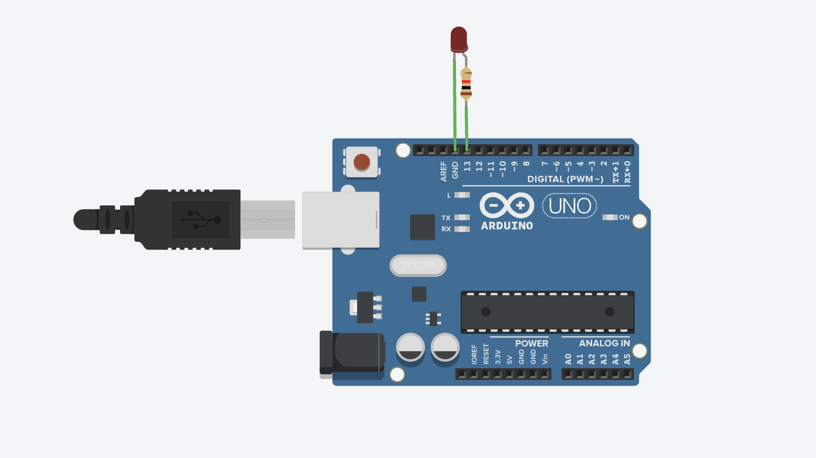

**Schematic Diagram :**

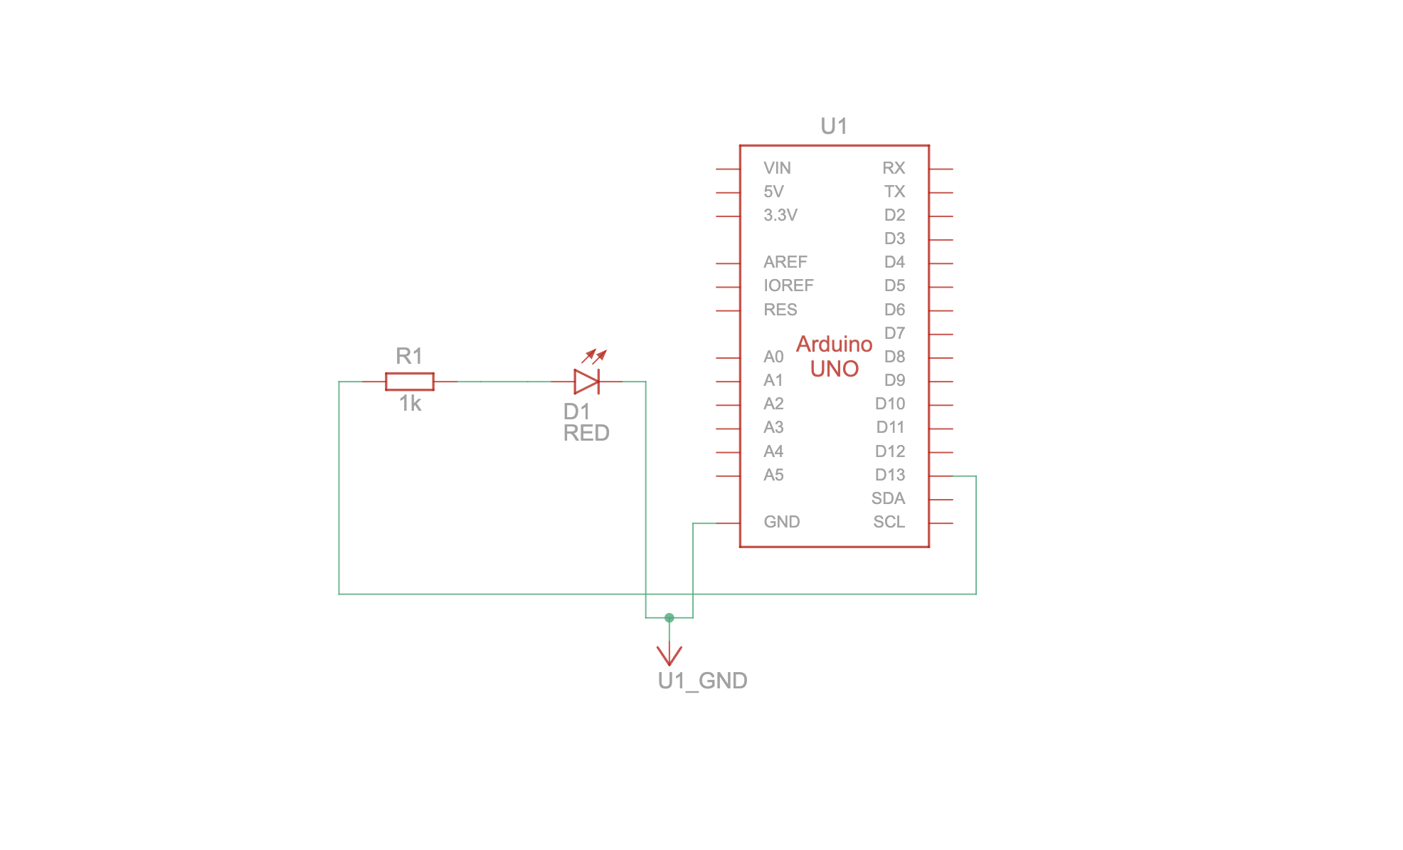

**Code :**

// C++

// Define the LED pin

int ledPin = 13;

// Setup function runs once when the program starts

void setup() {

// Set the LED pin as an OUTPUT

pinMode(ledPin, OUTPUT);

}

// Loop function runs repeatedly

void loop() {

// Turn the LED ON

digitalWrite(ledPin, HIGH);

// Wait for 1000 milliseconds (1 second)

delay(1000);

// Turn the LED OFF

digitalWrite(ledPin, LOW);

// Wait for 1000 milliseconds (1 second)

delay(1000);

}

**Results :**

The LED will blink on and off every 1 second. This is the result of the code that alternates between turning the LED on (HIGH) and off (LOW) with a delay of 1000 milliseconds (1 second).

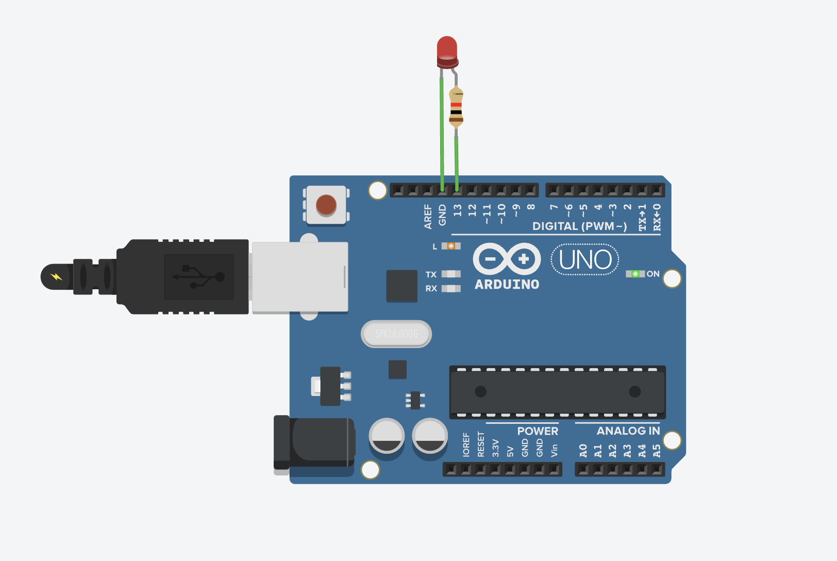

**Conclusion :**

The Blinking LED project successfully demonstrates the fundamental concept of controlling a digital output with an Arduino. The simulation in Tinkercad validates the design and functionality of the circuit, serving as an essential first step in learning IoT development. This project lays the groundwork for more advanced applications, such as integrating sensors or connecting to cloud services in future projects.